tickbound
What we are measuring, what we have found, and the rules we work by
MSc Clock Research (KCL) - CPU/GPU time synchronisation
Status: 8 October 2026. New: A100-SXM4-40GB and H100 80GB HBM3 runs of 8 October 2026 (layout 2, CUDA 12.6). Earlier: A100 and RTX 3060 runs of 6 October 2026 (layout 1).
Legend used throughout: [Measured] [Candidate - check literature] [Hypothesis] [Pending H100]
1. Summary 2
2. What the tool measures 2
2.1 Two clocks, one axis 2
2.2 The probe kernel (k_ktrace) and its 12 checkpoints (layout 2) 3
3. Results on A100 and H100 (8 October 2026) 3
3.1 Setup 3
3.2 The numbers (medians, 1 block per SM unless stated) 3
3.3 Figures 4
3.4 What the results say 7
4. Earlier data: A100 and RTX 3060 (6 October 2026, layout 1) 8
4.1 Setup 8
4.2 Inside the kernel (cycles, median, 1 block per SM, 256 threads) 8
4.3 Between the CPU and the GPU (ns, median; bound of section 4.1 applies on top) 8
4.4 How well the stamps are placed 9
4.5 The findings in plain words 9
5. What changed this week: layout 2 10
6. The rules we apply 10
6.1 Measurement rules (method) 10
6.2 Hardware behaviour the method relies on 11
6.3 Working rules (cost, safety, process) 11
7. Next steps 11
8. Limits of the evidence 12
Appendix: where the numbers come from 12

1. Summary
tickbound puts the CPU and the GPU on one time axis with a stated error bound on every number, and puts every warp of a probe kernel on that axis at checkpoints a few dozen cycles apart. On 8 October 2026 the corrected probe ran on a real A100 and a real H100 (CUDA 12.6 on both; the compiled-code check passed 56 of 56 on both). The main results:
- [Measured] every warp checkpoint on every SM is placed on one GPU time axis to ±20-21 ns on the H100 (timer tick 64 ns) and ±40-77 ns on the A100 (tick 1,024 ns);
- [Measured] the compute phase now measures the true FFMA latency: 4.01 (A100) and 4.03 (H100) cycles per FFMA, against 3.98 and 4.00 from the separate isolated-instruction profile - two independent methods agree within 1 %;
- [Measured] no instruction-fetch penalty: at 1 block per SM a 4,096-instruction straight chain (64 KB of code) still runs at 4.00 cycles per FFMA on both GPUs; with 4 blocks per SM the A100 slows to about 6 cycles per FFMA while the H100 stays near 4;
- [Measured] telling the CPU: the system fence after the done-flag costs 2.85 µs (A100) and 1.74 µs (H100); the CPU sees the flag 0.93 µs (A100) and 0.72 µs (H100) after it is written, while cudaStreamSynchronize returns 4.6 µs and 3.4 µs after the last warp is done;
- [Measured] the toolchain is part of the experiment: the CUDA 12.2 compiler inserted extra wait instructions into two timed steps on the H100 - the automatic check failed that build - and CUDA 12.6 did not;
- [Candidate - check literature] a timestamp taken right after __syncthreads() does not show the barrier release; tickbound times the release correctly (0 early releases in every launch on all three GPUs).
Nothing here is claimed to be new to the community yet. Items marked Candidate need a literature search before any such claim. GPU time for all 8 October runs: USD 1.07.

2. What the tool measures

2.1 Two clocks, one axis
- %globaltimer: one nanosecond timer for the whole GPU, but it only advances in steps (ticks): 1,024 ns on the A100 and RTX 3060; 64 ns expected on the H100.
- clock64: a cycle counter per SM, exact to the cycle, shared by every warp on that SM, not comparable across SMs.
- The host clock (CLOCK_MONOTONIC_RAW): tied to the GPU timer by a tick-edge clock sync run before and after every measurement, which yields a hard bound (for example ±757 ns on the A100 ktrace run).
Every checkpoint reads %globaltimer, clock64, %globaltimer. The true time of that cycle therefore lies between the first reading and the second reading plus one tick. Collecting these windows over all warps of a block bounds the block's cycle-to-nanosecond line far below the tick; that is how sub-tick placement is achieved.

2.2 The probe kernel (k_ktrace) and its 12 checkpoints (layout 2)
# | Checkpoint | What happens between this checkpoint and the next
0 | entry | nothing (measures the cost of one checkpoint: 14 cycles)
1 | cal | two dependent global loads (L2-resident) consumed by a shared store
2 | loaded | calibration chain: shared load + shared store
3 | bar1_arrive | first __syncthreads + the shared load that proves the release
4 | bar1_release | FFMA_N dependent FFMA (64, 256, 1024 or 4096), fully unrolled
5 | computed | shared load + store
6 | bar2_arrive | second __syncthreads + proof load
7 | bar2_release | one global store + GPU-scope fence
8 | stored | warp 0: grid-wide atomic ticket (orders blocks across SMs)
9 | ticket | third __syncthreads + ticket shared load + writer predicate
10 | flag | only the flag store into host memory (last block, thread 0)
11 | exit | end of the warp's timed work; the writer's system fence follows and is timed separately
Layout 1 (the 6 October data) had 11 checkpoints: no separate flag checkpoint, and the system fence sat inside the last phase.

3. Results on A100 and H100 (8 October 2026)

3.1 Setup
 | A100-SXM4-40GB | H100 80GB HBM3
SMs | 108 | 132
%globaltimer tick | 1,024 ns | 64 ns
SM clock during runs (fitted) | 1.07-1.14 GHz | 1.94-2.01 GHz
Host-GPU clock bound (ktrace / idle / long) | ±835 / ±782 / ±760 ns | ±654 / ±715 / ±713 ns
Compiler, compiled-code check (56 checks: 14 per FFMA_N instantiation) | CUDA 12.6, PASS 56/56 | CUDA 12.6, PASS 56/56 (CUDA 12.2 build: FAIL 16/56)
Runs | ktrace (1 and 4 blocks/SM), ktrace_idle, ktrace_long, FFMA sweep 64-4,096, isolated-instruction profile | same

3.2 The numbers (medians, 1 block per SM unless stated)
Quantity | A100 | H100
stamp placement on the GPU axis (±) | 77 ns (40 ns at 4/SM) | 21 ns (20 ns at 4/SM)
compute: cycles per FFMA (isolated latency) | 4.01 (3.98) | 4.03 (4.00)
load: 2 dependent loads (cycles) | 338 | 386
store + GPU-scope fence (cycles) | 628 | 1,534
grid-wide atomic ticket, warp 0 (cycles) | 403 | 498
flag store bracket beyond one checkpoint (cycles) | -2 | +2
system fence after the flag (writer) | 3,056 cy = 2.85 µs | 3,374 cy = 1.74 µs
launch call → first warp: warm / after 50 ms idle / cold (µs) | 6.4 / 9.8 / 32.6 | 5.2 / 24.4 / 39.6
kernel: first warp starts → last warp done (µs) | 6.27 | 4.02
flag written → host sees it (µs) | 0.93 | 0.72
last warp done → cudaStreamSynchronize returns (µs) | 4.62 | 3.37
cross-SM ticket-order violations | 0 of 540 / 2,160 | 0 of 660 / 2,640
barrier released before the last warp arrived | 0 | 0

3.3 Figures
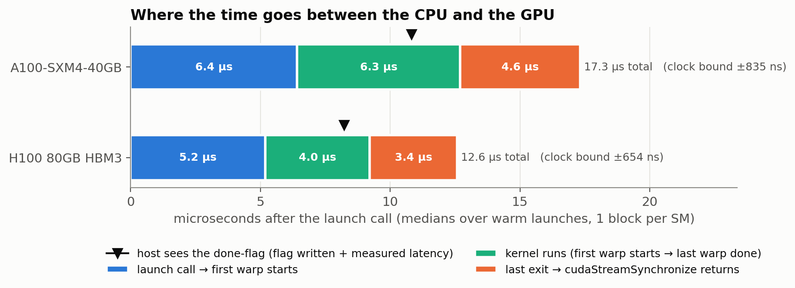
Figure 1. From the CPU's launch call to the CPU learning the kernel is done. The triangle marks when the host saw the done-flag; cudaStreamSynchronize returns later.
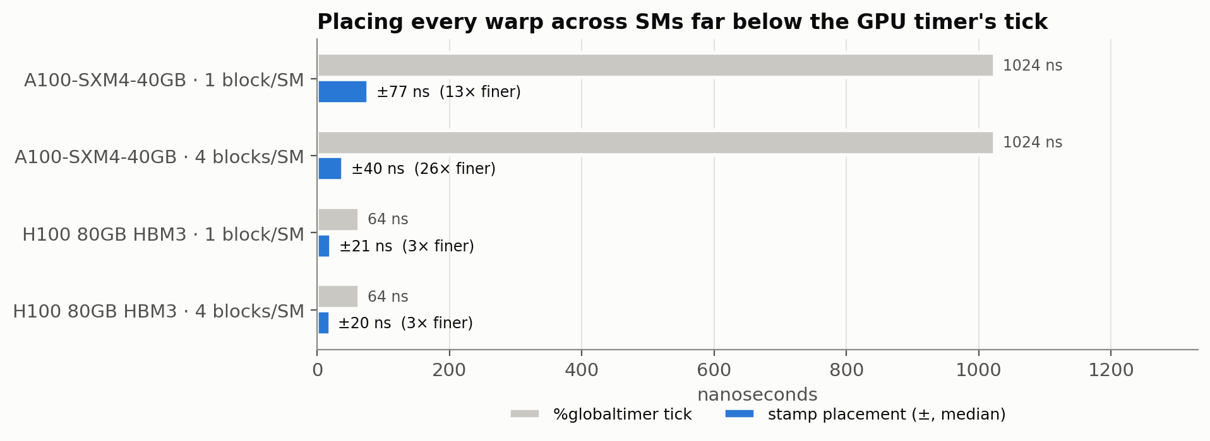
Figure 2. How precisely each stamp is placed on the common GPU axis, against the step of the GPU's own timer.
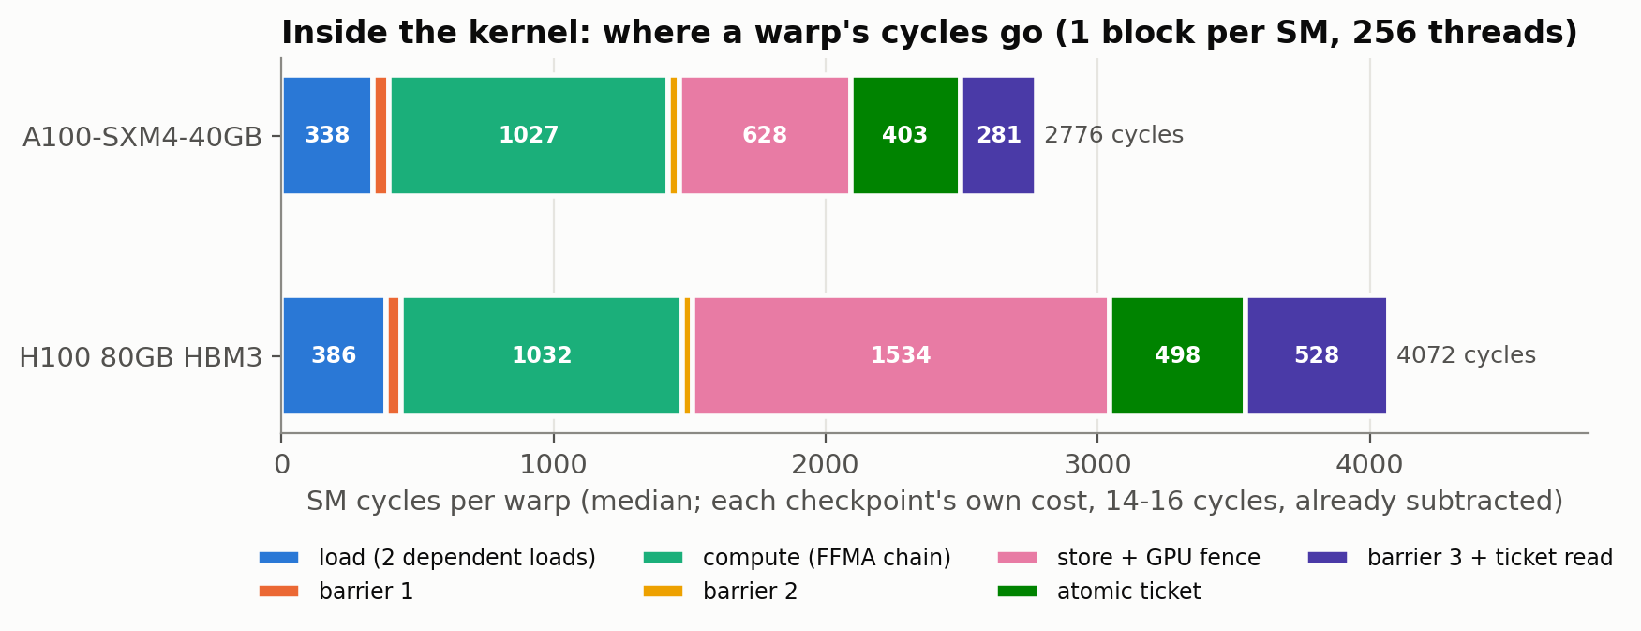
Figure 3. Each warp's cycles inside the probe kernel, phase by phase (compiled code checked for every phase).
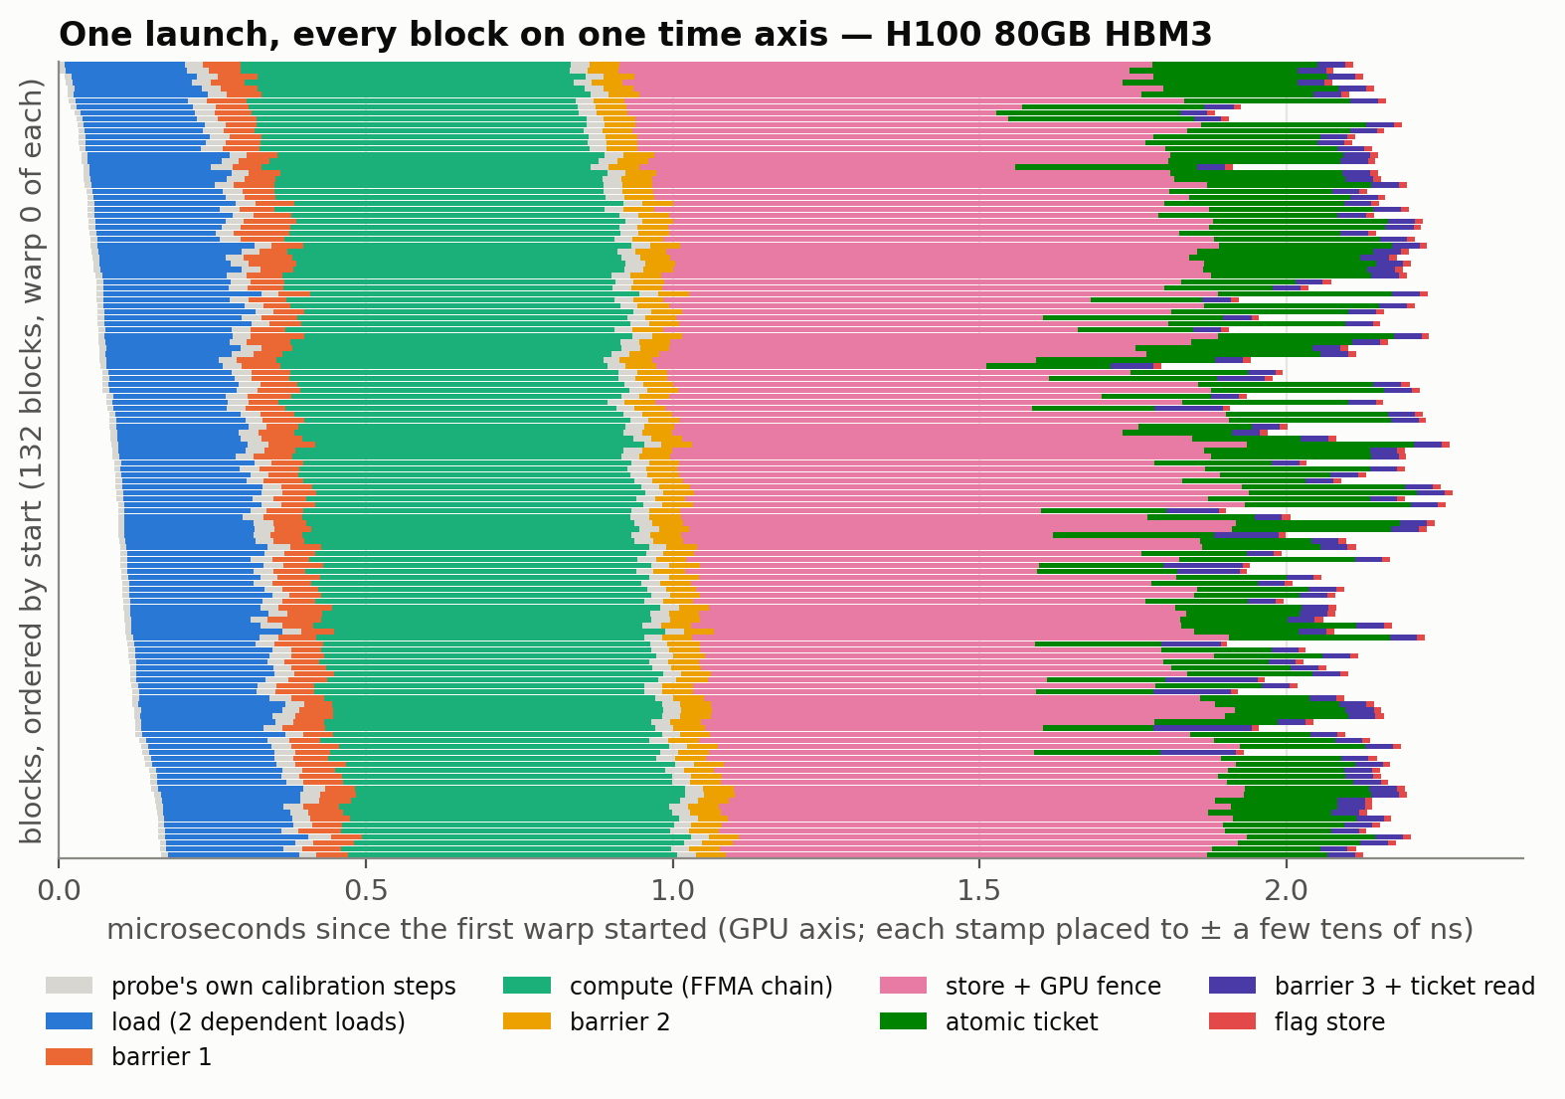
Figure 4. One H100 launch: every block's warp 0 on the GPU time axis, coloured by phase; grey = the probe's own calibration steps.
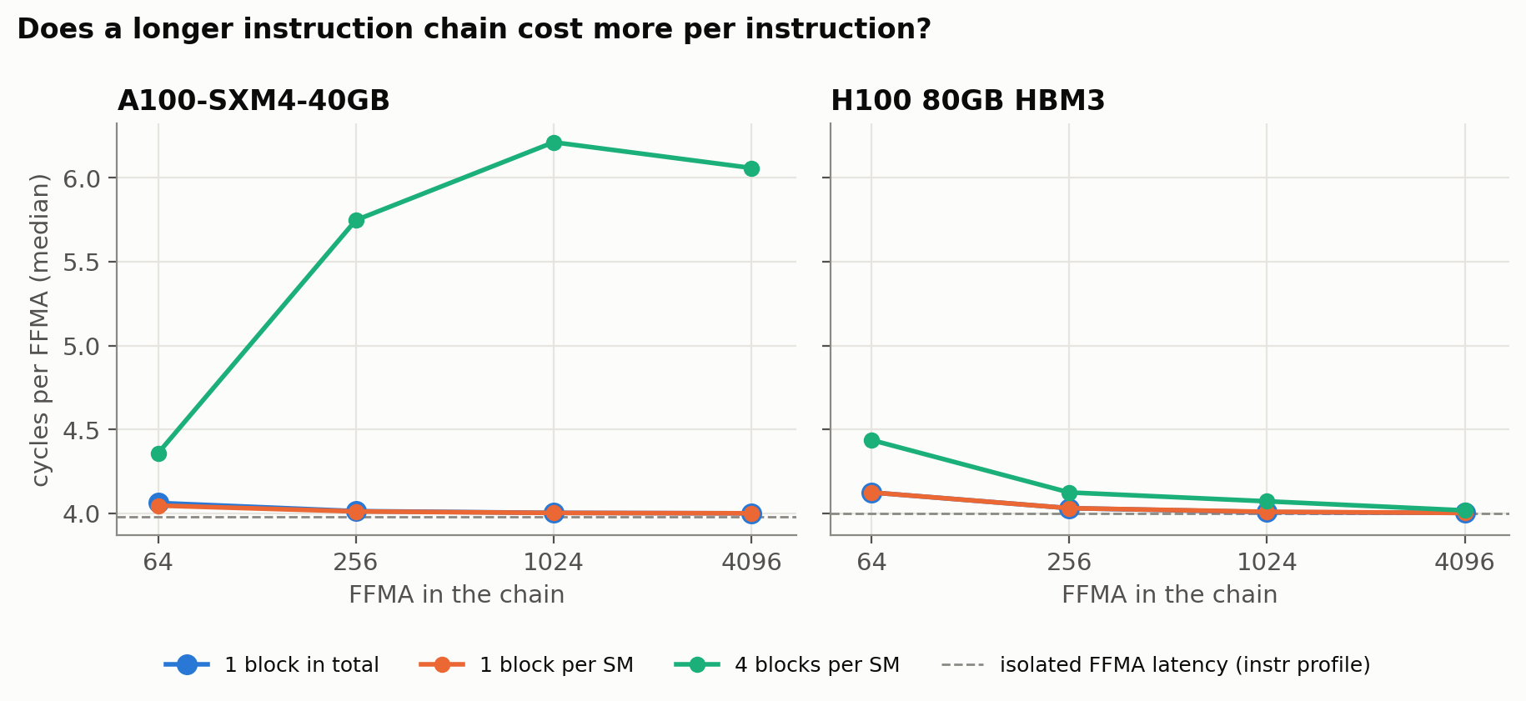
Figure 5. Cycles per FFMA against chain length. Flat at 1 block per SM: no instruction-fetch penalty even at 64 KB of code. With 4 blocks per SM the A100 slows, the H100 barely.
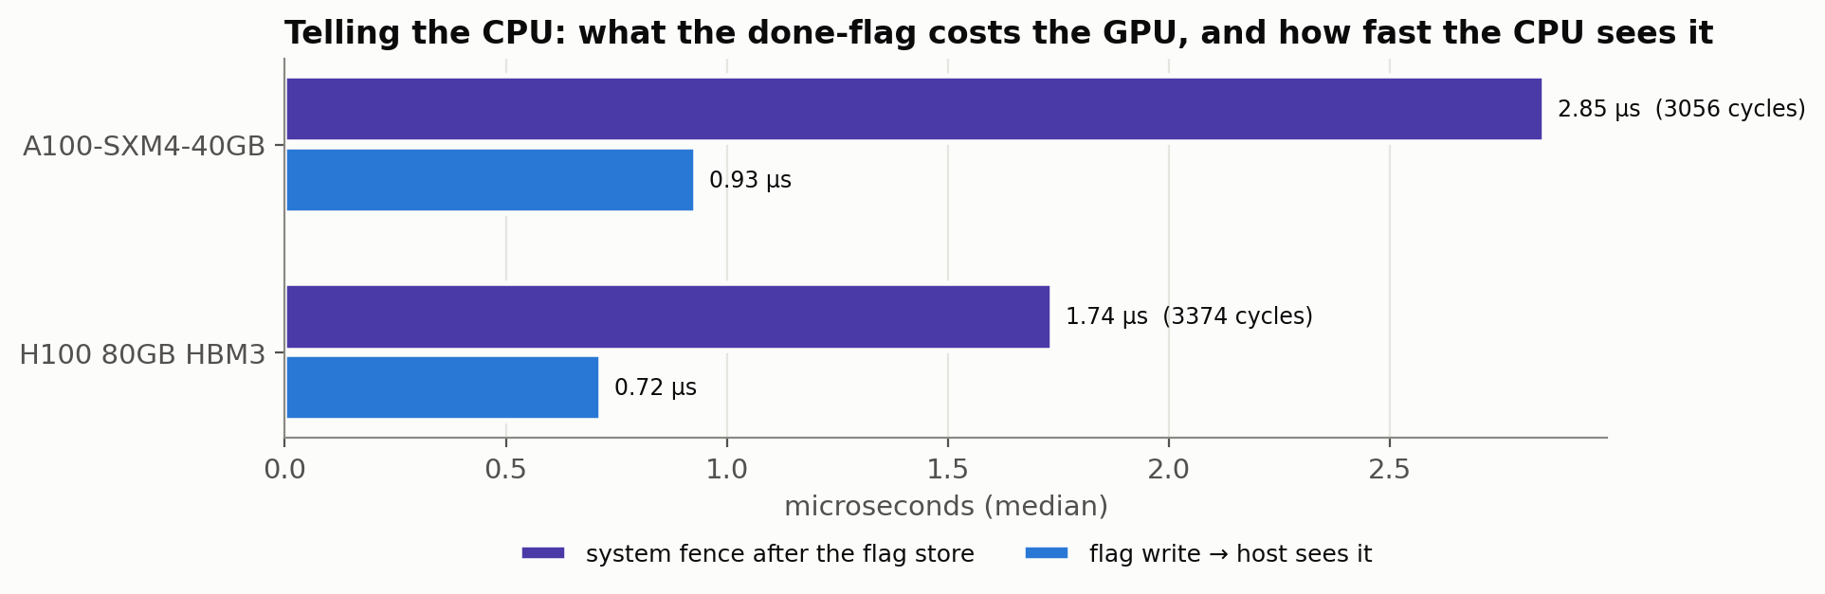
Figure 6. The done-flag: what its system fence costs the writing warp, and how fast the CPU sees the flag.
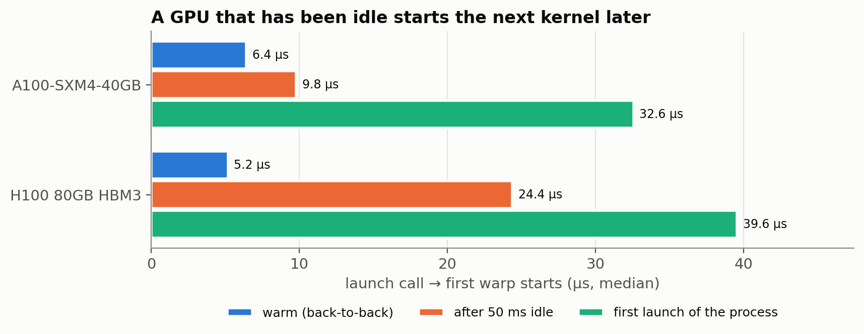
Figure 7. Launch call to first warp: warm, after 50 ms idle, and first launch of the process.
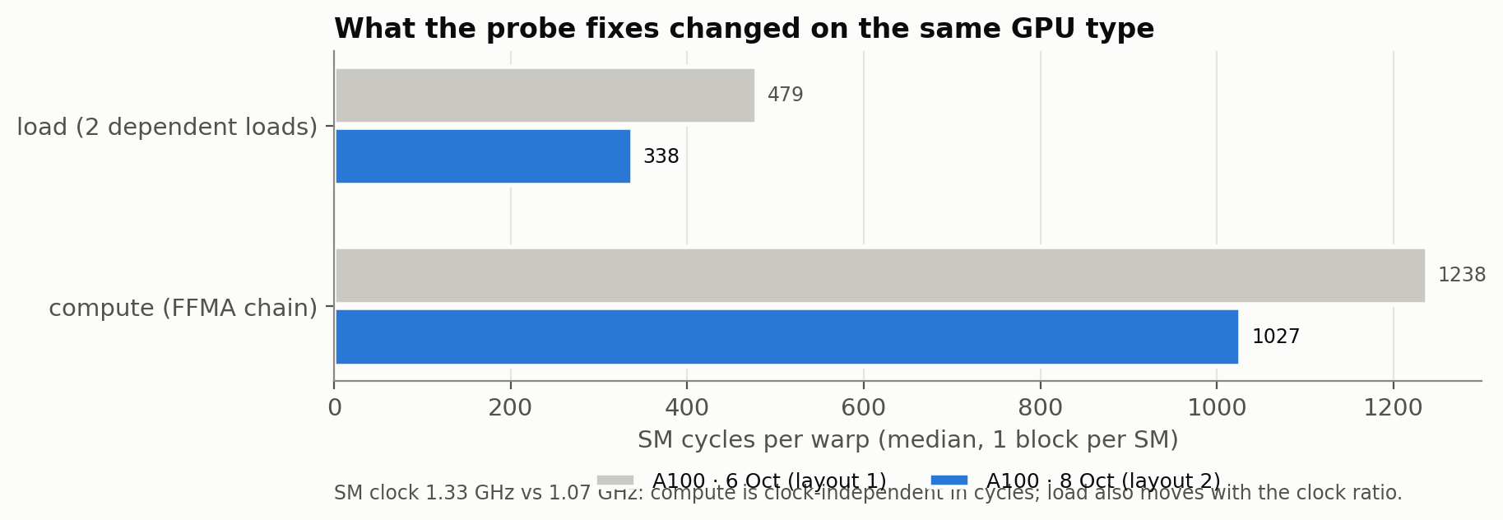
Figure 8. The probe fixes on the same GPU type (two different rented A100s; their SM clocks differ, which also moves the load phase).

3.4 What the results say
- [Measured] The compute phase is now the instruction itself. 4.01 / 4.03 cycles per FFMA inside the kernel against 3.98 / 4.00 from the isolated-instruction profile. On the same GPU type the compute phase dropped from 1,238 to 1,027 cycles for 256 FFMA: the ≈200 cycles of loop control are gone.
- [Measured] Placement scales with the timer tick, but always beats it. ±20-21 ns on the H100 (tick 64 ns, 3x finer) and ±40-77 ns on the A100 (tick 1,024 ns, 13-26x finer); no cross-SM ordering check ever failed.
- [Measured] No instruction-fetch penalty for long straight-line code. At 1 block per SM, 64 to 4,096 FFMA all run at 4.00-4.12 cycles per FFMA on both GPUs. The instruction-cache hypothesis written down before the run is rejected by the data.
- [Measured] [Hypothesis] Contention differs by architecture. With 4 blocks per SM (3 resident) the A100 rises to 5.75-6.21 cycles per FFMA, the H100 only to 4.02-4.44. This fits the documented FP32 width: 16 lanes per scheduler on the A100 (a warp FFMA occupies the pipe for 2 cycles) against 32 on the H100.
- [Measured] Telling the CPU is expensive on the GPU side, fast on the CPU side. The writer's system fence costs 2.85 µs (A100) and 1.74 µs (H100); the CPU sees the flag 0.93 / 0.72 µs after the write; synchronize returns 4.6 / 3.4 µs after the last warp. The flag store itself costs nothing measurable beyond a checkpoint (-2 / +2 cycles).
- [Measured] The H100's GPU-scope fence is slower. Store + __threadfence() takes 1,534 cycles (≈0.78 µs) on the H100 against 628 cycles (≈0.58 µs) on the A100.
- [Measured] Idle penalty depends on the machine. After 50 ms idle the first warp starts 1.5x later on this A100 (9.8 vs 6.4 µs) but 4.7x later on the H100 (24.4 vs 5.2 µs); the A100 box of 6 October showed 2.9x. Power management, driver and host differ per rented machine.
- [Measured] The compiler version changes what is measured. The CUDA 12.2 compiler put DEPBAR wait instructions inside the load and flag phases; the automatic check flagged that build (16 of 56 checks failed) and the H100 was re-run with CUDA 12.6 (56 of 56).

4. Earlier data: A100 and RTX 3060 (6 October 2026, layout 1)

4.1 Setup
 | A100-SXM4-40GB | RTX 3060
SMs | 108 | 28
%globaltimer tick | 1,024 ns | 1,024 ns
SM clock during runs (fitted) | 1.32-1.39 GHz | 1.60-1.92 GHz
Host-GPU clock bound per run | ±757 / ±944 / ±852 ns | ±329 / ±338 / ±333 ns
Runs | ktrace (1 and 4 blocks/SM), ktrace_idle (50 ms idle), ktrace_long (4,096 FFMA) | same
Launches per configuration | 5 (3 for ktrace_long) | 5 (3 for ktrace_long)

4.2 Inside the kernel (cycles, median, 1 block per SM, 256 threads)
Phase | A100 | RTX 3060 | Note
one checkpoint (3 timer reads) | 14 | 14 | subtracted from every phase
load: 2 dependent loads | 479 | 512 | layout 1 also counted 2 S2R + address maths
barrier 1: wait / release | 39 / 33 | 56 / 35 | release never before the last arrival
compute: 256 dependent FFMA | 1,238 | 1,237 | ≈200 cycles were loop control (fixed)
store + GPU-scope fence | 644 | 569
grid-wide atomic ticket (warp 0) | 298 | 282
tail: barrier 3 + flag, all warp 0s | ≈110 | ≈117 | raw c[10]-c[9]
tail of the flag-writing warp | ≈3,546 | ≈1,868 | includes the system fence

4.3 Between the CPU and the GPU (ns, median; bound of section 4.1 applies on top)
Interval | A100 (1 block/SM) | RTX 3060 (1 block/SM)
launch call → first warp starts (warm) | 6,627 | 3,942
same, first launch of the process (cold) | 35,914 | 30,879
same, after 50 ms idle | 19,311 | 36,775
kernel span (first entry → last exit) | 5,828 | 2,952
flag written → host sees it | 699 (310-1,089) | 290 (86-520)
last warp exit → cudaStreamSynchronize returns | 4,400 | 1,564
same, after 50 ms idle | 6,714 | 8,412
Brackets: the flag latency's lower and upper bound from the write window. At 4 blocks per SM the RTX 3060 median was 24 ns with bounds -488 to +426 ns, i.e. inside the clock bound, so it is not quoted as a latency.

4.4 How well the stamps are placed
Check | A100 | RTX 3060
placement uncertainty per block (±, median over launches) | 53 ns (1/SM), 38 ns (4/SM), 46 ns (idle), 77 ns (long) | 162 ns (1/SM), 78 ns (4/SM), 129 ns (idle), 54 ns (long)
cross-SM ticket-order violations | 0 in 540 / 2,160 / 540 / 1,296 | 0 in 140 / 560 / 140 / 336
barrier released before the last warp arrived | 0 | 0
clock-rate inconsistency across blocks | 0-36 ns | 0-47 ns (long launches)

4.5 The findings in plain words
- [Measured] Sub-tick placement. Every warp checkpoint on every SM lands on one GPU time axis with a median uncertainty of 38-77 ns on the A100 (54-162 ns on the RTX 3060), 13-27 times finer than the 1,024 ns timer tick. The only cross-SM consistency check (the order of the grid-wide atomic ticket) never failed. [Candidate - check literature] whether this per-SM tick-edge placement is already published.
- [Candidate - check literature] Barrier timing pitfall. __syncthreads() compiles to BAR.SYNC.DEFER_BLOCKING: a warp keeps issuing non-memory instructions, a clock read included, until it reaches a memory instruction. In the first RTX 3060 run a stamp right after the barrier read 13 cycles after the warp's own arrival whether or not the others had arrived. tickbound stamps after a shared load that waits for the barrier; with that, 0 early releases were seen in every A100 and RTX 3060 launch. This is observed behaviour, not a documented guarantee.
- [Measured] Cost of telling the CPU. The warp that writes the done-flag into host memory and fences at system scope spends about 3,546 cycles in its last phase against about 110 for every other warp 0 (A100), i.e. about 3,400 extra cycles or 2.6 µs at 1.33 GHz; about 1,868 vs 117 cycles (≈1 µs) on the RTX 3060. Layout 2 measures the fence directly.
- [Measured] Polling beats synchronising. The host typically sees the flag 0.3-1.0 µs after it is written, while cudaStreamSynchronize returns 1.5 µs (RTX 3060) to 4.5 µs (A100) after the last warp ends: for latency-critical code a mapped-flag poll learns of completion one to several microseconds earlier.
- [Measured] Idle penalty. After 50 ms without work the next launch reaches its first warp 3x (A100) to 9x (RTX 3060) later, and synchronisation after the kernel is slower too. This fits a power-state wake-up; the effect is broadly known, the bounded numbers are ours.
- [Measured] The probe's own cost. One checkpoint costs 14 cycles. In layout 1 the compute phase carried about 200 cycles of loop control (≈16 %), and the load phase carried thread-index reads and address maths: both fixed in layout 2.
- [Measured] GPU code checked without a GPU. NVRTC (from pip) plus NVIDIA's cuobjdump reproduce the per-phase instruction counts of the real nvcc builds from the A100 and RTX 3060 boxes, so kernel changes are verified locally before any GPU is rented.

5. What changed this week: layout 2
Timed step | Flaw in layout 1 | Fix in layout 2
flag write to host | write time known only within ≈0.5 µs: the stamp came after barrier 3, a timer read, the store and the system fence | two stamps bracket only the store; the writer's fence follows the exit stamp and is timed separately; old-style durations still reported
load | included 2 thread/block index reads and address maths (≈6 instructions) | all of it moved before the first stamp; the phase is 2 loads + the inherent address step + the consuming store
compute | loop of 16 FFMA: 5 branches + counters inside (≈200 cycles) | template, fully unrolled: exactly 1 FADD + FFMA_N FFMA; --ffma limited to 64/256/1024/4096
Verification:
- compiled GPU code for A100, RTX 3060 and H100 targets: 56 exact checks per architecture (14 per chain length: every timed step, every calibration step, the writer's fence, no spills, no stray clock reads) pass; 80 registers;
- the checker fails on every one of 168 deliberately broken builds (14 mutations x 4 chain lengths x 3 architectures: extra instruction, constant reload, spill, lost stamp, dropped fence, ...);
- the 6 October data re-analyses to exactly the same values (0 changed out of 749 / 391 / 319 values per run);
- 33 automated tests pass; four independent reviewers (compiled code, old-data compatibility, measurement meaning, tools and docs) checked two rounds and passed the final one;
- on real GPUs (8 October): the host code compiled with nvcc; the compiled-code check passed 56/56 on the A100 and the H100 with CUDA 12.6, and caught the CUDA 12.2 build (16 failures).

6. The rules we apply

6.1 Measurement rules (method)
- Every number has a bound. Each host-GPU number is reported with its hard bound from the tick-edge clock sync taken before and after the run; GPU-axis placements carry their own half-width.
- Never hide an inconsistency. When constraints disagree (rate inconsistency), the smallest widening that restores them is reported, never smoothed away.
- A timed step contains only what its name says. Proven in the compiled code (SASS) for every build: an automatic gate prints PASS/FAIL in the run report.
- Calibrate the probe. The cost of a checkpoint (14 cycles) and of the post-barrier proof chain are measured in the same launch and subtracted.
- No memory traffic inside timed steps. Stamps stay in registers and are written once, at the end of the warp.
- Built-in falsification checks. A barrier may never release before the last warp arrives (exact, in cycles); the atomic ticket order must agree across SMs; the host must see the flag after it was written.
- Old data must not move. After any change, every earlier dataset is re-analysed and compared value by value; any changed value blocks the change.
- Hypothesis is not fact. Explanations not yet tested (for example instruction fetch vs issue contention in long FFMA chains) are written as hypotheses with the experiment that would decide them.
- The compiler is part of the experiment. The CUDA version is recorded with every run and the compiled code of the binary that measured is checked; a different compiler can change what a timed step contains.
- Say what the tool is not. tickbound times its own probe kernels; it is not a profiler for unmodified kernels (no binary patching, NVBit, CUPTI or PC sampling); third-party code such as cuPHY gets only start/end stamps.

6.2 Hardware behaviour the method relies on
- clock64 is one counter per SM: shared by all its warps (checked on the data: no per-warp offset); never compared across SMs directly.
- %globaltimer is GPU-wide but coarse: 1,024 ns ticks on A100/RTX 3060 (64 ns expected on H100); a reading pair brackets the true time.
- One GPU clock drives every SM in a launch: so all blocks of a launch share one cycle-to-ns rate (allowing 0.1 % modulation).
- A load's wait attaches to its first consumer: so a stamp must follow an instruction that uses the loaded data (a volatile shared store), not the load itself.
- __syncthreads defers blocking: so the release is observed through a shared load issued after the barrier (observed on A100 and RTX 3060, not documented).
- The compiler may move independent instructions across clock reads: so the compiled SASS, not the source, is the ground truth for what a phase contains.

6.3 Working rules (cost, safety, process)
- Money: GPU rentals only after approval; each run has a hard cost cap (USD 3 for the H100) and a timer that destroys the machine whatever happens; results copied back over SSH, then the machine is destroyed.
- Keys: the vast.ai key is never written to a file or a repo; it should be regenerated because it was pasted into a chat.
- Verify before renting: local compiled-code checks, tests and the old-data regression must pass, and the change is reviewed adversarially, before GPU time is bought.
- Nothing published without consent: tickbound is not committed or pushed; the research repo is public, so code goes there only on request.
- Naming: the tool is tickbound (TempoTrace is another group's paper; boundline is the backup name).

7. Next steps
- Literature check of the Candidate items (sub-tick per-SM placement, barrier timing pitfall, fence and flag costs) before any novelty claim.
- More launches per configuration (5 today) for tighter medians and tails, ideally on the same machine twice to separate machine from GPU effects.
- Towards a profiler: stamp macros that users put into their own kernels, reusing the compiled-code check and the analysis; CUPTI start/end times placed on the bounded axis.
- Later: bracket a single load instruction's issue and return (CuAssembler), and a two-GPU ping-pong for cross-GPU synchronisation.

8. Limits of the evidence
- Small samples: 5 launches per configuration (3 for the long runs) on one rented machine per GPU type.
- Rented machines: GPU clocks could not be locked; SM clock is fitted per launch from the data.
- Medians are reported; the analysis files hold p90, p99 and maxima for every figure.
- Host-axis numbers carry the run's clock bound (±329 to ±944 ns here) on top of the GPU-axis half-width.
- Each GPU type was measured on one rented machine per day; the two A100s differ (SM clock 1.33 vs 1.08 GHz, idle penalty 2.9x vs 1.5x).

Appendix: where the numbers come from
- Research repo PierreKhoury1/Final_year_research_MSc, branch claude/optimistic-ptolemy-r42xrh, slotbench/data/2026-10-06_a100_ktrace and 2026-10-06_3060_ktrace (A100 box: driver 580.159.03, CUDA 13.0).
- Analysed with tickbound (C:\Users\pierr\tickbound) as of 7-8 October 2026; per-run analysis JSON is reproducible with `tickbound analyze PREFIX --json OUT`.
- Writer-warp tail figures: c[exit] - c[ticket] of warp 0 in the block holding the highest ticket, median over launches (A100 n = 10 ktrace, 3 long; RTX 3060 n = 10, 3).
- 8 October data: Desktop\MSc Clock Research\tickbound_data\2026-10-08_a100_cuda12.6 and 2026-10-08_h100_cuda12.6 (plus the CUDA 12.2 H100 run); figures and report: Desktop\MSc Clock Research\figures_2026-10-08 (PNG, SVG, report.html).
- Review record and open items: C:\Users\pierr\tickbound\CHECKPOINT.md.

